CalSmart



Calsmart is introduced either as an assignment or in canvas notifications.

Canvas Notifications

Student Registers on CalSmart.com with University credentials.



Student completes assignments as normal.

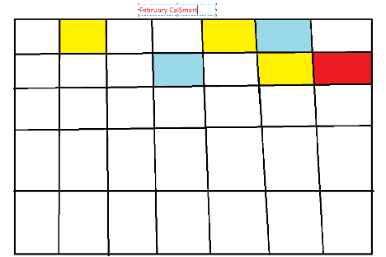CalSmart Populates the calendar based on data gained during the previous week. Color coded format organizes assignments by type and level of importance.

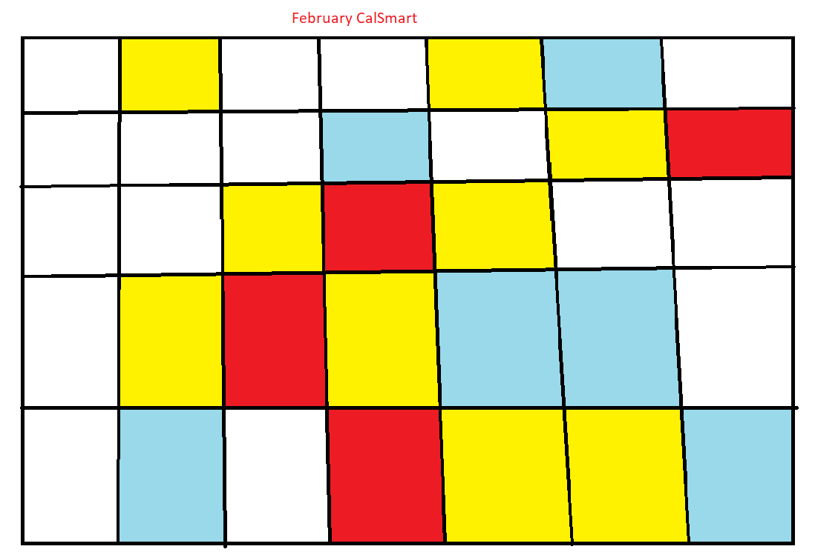CalSmart suggestions become more accurate with data.

Student maintains scheduling suggestions and ends up improving GPA and telling classmates.

